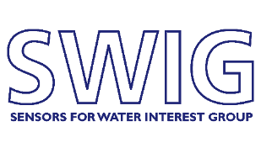

Water Quality Monitoring for Aquaculture

AGENDA

09:15 Refreshments & Registration
09:45 xxx: Welcome and Introduction
10:00 TBC
10:30 Beth Osborne – Loch Duarte: Salmon Aquaculture in a changing environment: an overview of salmon biology and the risks to health and welfare in a dynamic environment
11:00 Refreshments & Networking

11:30 Callum Whyte – SAMS: Innovative AI Solutions for Monitoring Harmful Algal Blooms in Aquaculture
12:00 Kevin Quillien – Krucial:
12:30 Nathan Lawrence – ANB Sensors
13:00 Lunch & Networking

14:00 Ryan Mowatt – RS Aqua: Real-Time Underwater Sensors for Sustainable Fish Farming
14:30 Jack Jarvis – University of Exeter: Water Chemistry Conditions Experienced by Farmed Rainbow Trout
15:00 Aquamonitrix?
15:30 Panel Discussion
16:00 Close

